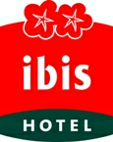
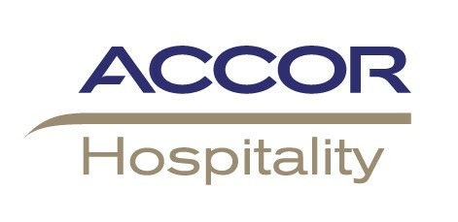
IBIS BUDAPEST EMKE Hotel accommodation booking form
ICHST 2009, Budapest, 27 July – 3 August
A hotel in modern style just a few minutes from the downtown
with 84 air-conditioned rooms.
Specially discounted hotel prices have been arranged for the participants at Ibis Budapest Emke. To make a reservation please complete this booking form as soon as possible and return it to Ibis Budapest Emke. We recommend you to book early as our allocation and special prices are subject to availability.

RESERVATION DETAILS

Please complete one form per room
Double for single use  rate: 78 Euro / night
smoking  non-smoking 
Double  rate: 87 Euro / night
Please tick the convenient room type
The prices include the buffet breakfast, all taxes.
Reservation deadline : 30th of April, 2009
First name of Delegate: __________________________________________________________
Last name: __________________________________________________________
Name of person sharing room: __________________________________________________________
Arrival date: _____________________ Departure date: __________________ No. of nights: ______
Organisation: _____________________________________
Address: ____________________________________________________________________________
Tel.: _______________ Fax.: _______________ E-mail: __________________________________
Lack of correct credit/bank card details or in case of unsuccessful authorisation we can not guarantee the reservation.
Credit Card Company: (Visa, Amex, Master ect.) ______________
Number: _____________________________ Exp. Date: _______________________
Card holders name: _____________________________________________________
I accept the conditions below and allow the hotel to authorise my credit card with total cost of my stay.
__________________________________________________
Authorised Signature

BOOKING / PAYMENT INFORMATION

- Above conference rates are available until 30th of May, 2009., After 30th of May, 2009, - or earlier if the allotment gets sold out confirmation of accommodation is subject to availability.
- After receiving your reservation form, your booking will be reconfirmed and your credit card will be charged for 1 (one) night.
- In case of no-show, late cancellation – after 30th of May, 2009. 1 (one) night deposit is non refundable.
- Check-in time: from 14 PM, check-out: until 12 AM (noon)
MAIL/FAX THIS FORM AS SOON AS POSSIBLE TO IBIS BUDAPEST EMKE:
H-1072 Budapest, Akácfa u. 1-3., Hungary
Telephone: +36 1 478-3050 Fax: +36 1 478 3055 e-mail: h1681-fo@accor.com
www.ibishotel.com

Confirmed by the hotel Sign: _________________________ Date: _______________

